Year Group Age-Related Expectations
Assessment
Yr 1 - Yr 6

Year One: ARE Music Assessment
Singing:
Sing simple songs, chants and rhymes from memory, singing collectively and at the same pitch, responding to simple visual directions (e.g. stop, start, loud, quiet) and counting in.
Sing a wide range of call and response songs to control vocal pitch and to match the pitch they hear with accuracy.

Listening:
Develop a shared knowledge and understanding of the stories, origins, traditions, history and social context of the music listened to, sung and played.

Composition:
Improvise simple vocal chants, using question and answer phrases.
Create musical sound effects and short sequences of sounds in response to stimuli, e.g. a rainstorm or a train journey. Combine to make a story, choosing and playing classroom instruments (e.g. rainmaker) or sound-makers (e.g. rustling leaves).
Understand the difference between creating a rhythm pattern and a pitch pattern.
Invent, retain and recall rhythm and pitch patterns and perform these for others, taking turns.
Recognise how graphic notation can represent created sounds. Explore and invent own symbols, for example:
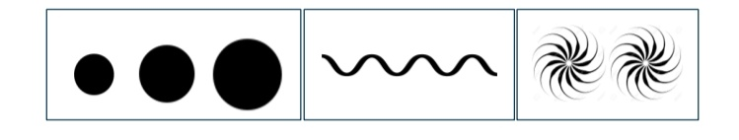

Musicianship:
Pulse/Beat :
Walk, move or clap a steady beat with others
Change the speed of the beat as the tempo of the music changes
Use body percussion, (e.g. clapping, tapping, walking) and classroom percussion (shakers, sticks and blocks, etc.), playing repeated rhythm patterns (ostinati) and short, pitched patterns on tuned instruments (e.g. glockenspiels or chime bars) to maintain a steady beat.
Respond to the pulse in recorded/live music through movement and dance

Rhythm:
Perform short copycat rhythm patterns accurately, led by the teacher.
Perform short repeating rhythm patterns (ostinati) while keeping in time with a steady beat.
Perform rhythms from written notation); create, retain and perform their own rhythm patterns.

Pitch:
Listen to sounds comparing high and low.
Sing familiar songs in both low and high voices and talk about the difference in sound.
Explore percussion sounds to enhance storytelling

Year Two: ARE Music Assessment
Singing:
Sing songs regularly with increasing vocal control
Know the meaning of dynamics (loud/quiet) and tempo (fast/slow) and be able to demonstrate these when singing by responding to (a) the leader's directions and (b) visual symbols (e.g. crescendo, decrescendo, pause)
Listening:
Develop a shared knowledge and understanding of the stories, origins, traditions, history and social context of the music listened to, sung and played.

Composition:
Create music in response to a non-musical stimulus (e.g. a storm, a car race, or a rocket launch).
Work with a partner to improvise simple question and answer phrases, to be sung and played on untuned percussion, creating a musical conversation.
Use graphic symbols, dot notation and stick notation, as appropriate, to keep a record of composed pieces.

Musicianship:
Pulse/Beat:
Understand that the speed of the beat can change, creating a faster or slower pace (tempo).
Mark the beat of a listening piece by tapping or clapping and recognising tempo as well as changes in tempo.
Walk in time to the beat of a piece of music or song
Know the difference between left and right to support coordination and shared movement with others.
Begin to group beats in twos and threes by tapping knees on the first (strongest) beat and clapping the remaining beats.
Identify the beat groupings in familiar music that they sing regularly and listen to

Rhythm:
Play copycat rhythms, copying a leader, and invent rhythms for others to copy on untuned percussion.
Create rhythms using word phrases as a starting point (e.g. Hel-lo Si-mon or Can you come and play?).
Read and respond to chanted rhythm patterns, and represent them with stick notation including crotchets, quavers and crotchets rests.
Create and perform their own chanted rhythm patterns with the same stick notation

Pitch :
Play a range of singing games based on the cuckoo interval (so-mi) matching voices accurately, supported by a leader playing the melody.
Sing short phrases independently within a singing game or short song.
Respond independently to pitch changes heard in short melodic phrases, indicating with actions (e.g. stand up/sit down, hands high/hands low).
Recognise dot notation and match it to 3-note tunes played on tuned percussion

Indicative Musical Features Expected for KS2 Music:

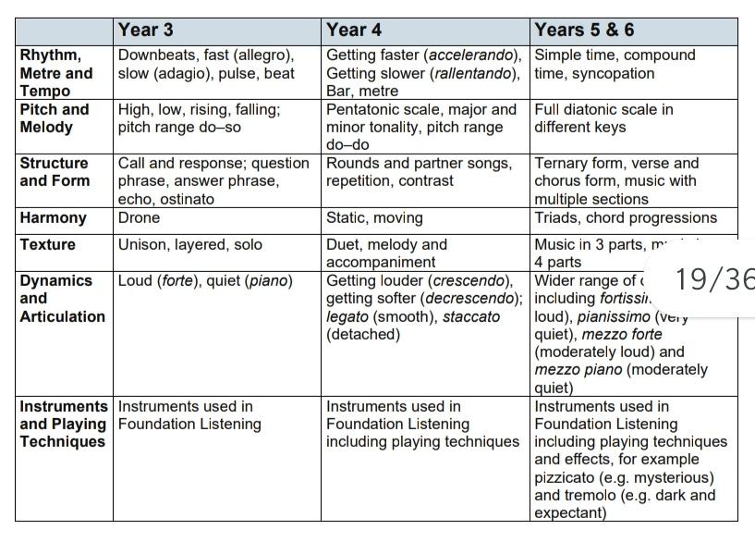
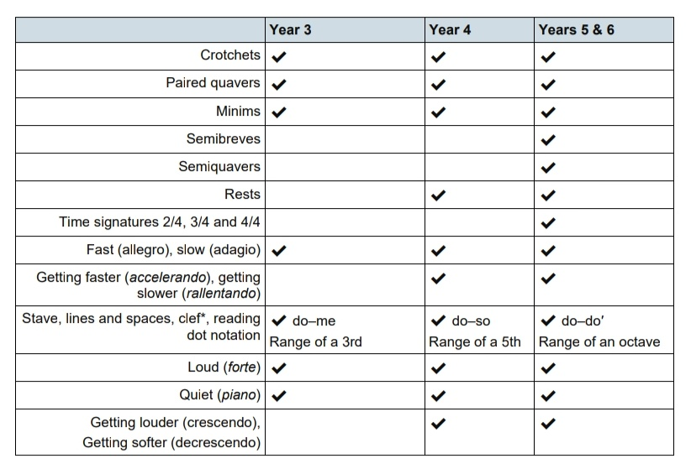

Year Three: ARE Music Assessment
Singing:
Sing a widening range of unison songs of varying styles and structures with a pitch range of do–so tunefully and with expression.
Perform forte and piano, loud and soft.
Perform actions confidently and in time to a range of action songs
Walk, move or clap a steady beat with others, changing the speed of the beat as the tempo of the music changes.
Perform as a choir in school assemblies

Listening:
Develop a shared knowledge and understanding of the stories, origins, traditions, history and social context of the music listened to, sung and played.

Composition:
Become more skilled in improvising (using voices, tuned and untuned percussion and instruments played in whole-class/group/individual/instrumental teaching), inventing short ‘on-the-spot’ responses using a limited note-range.
Structure musical ideas (e.g. using echo or question and answer phrases) to create music that has a beginning, middle and end. Pupils should compose in response to different stimuli, e.g. stories, verse, images (paintings and photographs) and musical sources.
Combine known rhythmic notation with letter names to create rising and falling phrases using just three notes (do, re and mi).
Compose song accompaniments on untuned percussion using known rhythms and note values.

Performing:
Develop facility in playing tuned percussion or a melodic instrument
Play and perform melodies following staff notation using a small range (e.g. Middle C–E/do–mi) as a whole class or in small groups (e.g. trios and quartets).
Use listening skills to correctly order phrases using dot notation, showing different arrangements of notes C-D-E/do-re-mi (dictation)

Reading Notation:
Introduce the stave, lines and spaces, and clef.
Use dot notation to show higher or lower pitch.
Introduce and understand the differences between crotchets and paired quavers.
Apply word chants to rhythms, understanding how to link each syllable to one musical note.

Year Four: ARE Music Assessment
Singing:
Continue to sing a broad range of unison songs with the range of an octave (do–do) pitching the voice accurately and following directions for getting louder (crescendo) and quieter (decrescendo).
Sing rounds and partner songs in different time signatures (2, 3 and 4 time) and begin to sing repertoire with small and large leaps as well as a simple second part to introduce vocal harmony
Perform a range of songs in school assemblies.

Listening:
Develop a shared knowledge and understanding of the stories, origins, traditions, history and social context of the music listened to, sung and played.

Composition:
Improvise on a limited range of pitches on the instrument they are now learning, making use of musical features including smooth (legato) and detached (staccato).
Begin to make compositional decisions about the overall structure of improvisations. Continue this process in the composition tasks below.
Combine known rhythmic notation with letter names to create short pentatonic phrases using a limited range of 5 pitches suitable for the instruments being learnt.
Sing and play these phrases as self-standing compositions.
Arrange individual notation cards of known note values (i.e. minim, crotchet, crotchet rest and paired quavers) to create sequences of 2-, 3- or 4-beat phrases, arranged into bars.
Explore developing knowledge of musical components by composing music to create a specific mood, for example creating music to accompany a short film clip.
Introduce major and minor chords.
Capture and record creative ideas using any of: graphic symbols, rhythm notation and time signatures, staff notation.
Performing:
Instrumental Performance
Play and perform melodies following staff notation using a small range (e.g. Middle C–G/do–so) as a whole-class or in small groups.
Perform in two or more parts (e.g. melody and accompaniment or a duet) from simple notation using instruments played in whole class teaching.
Identify static and moving parts.
Copy short melodic phrases including those using the pentatonic scale (e.g. C, D, E, G, A).

Reading Notation:
Introduce and understand the differences between minims, crotchets, paired quavers and rests.
Read and perform pitch notation within a defined range (e.g. C–G/do–so).
Follow and perform simple rhythmic scores to a steady beat: maintain individual parts accurately within the rhythmic texture, achieving a sense of ensemble.

Year Five: ARE Music Assessment
Singing:
Sing a broad range of songs from an extended repertoire with a sense of ensemble and performance. This should include observing phrasing, accurate pitching and appropriate style.
Sing three-part rounds, partner songs, and songs with a verse and a chorus.
Perform a range of songs in school assemblies and in school performance opportunities.

Listening:
Develop a shared knowledge and understanding of the stories, origins, traditions, history and social context of the music listened to, sung and played.

Composition:
Improvise freely over a drone, developing sense of shape and character, using tuned percussion and melodic instruments.
Improvise over a simple groove, responding to the beat, creating a satisfying melodic shape; experiment with using a wider range of dynamics, including very loud (fortissimo), very quiet (pianissimo), moderately loud (mezzo forte), and moderately quiet (mezzo piano). Continue this process in the composition tasks below.
Compose melodies made from pairs of phrases.
Working in pairs, compose a short ternary piece.
Use chords to compose music to evoke a specific atmosphere, mood or environment. Equally, pupils might create music to accompany a silent film or to set a scene in a play or book.
Capture and record creative ideas using any of: graphic symbols, rhythm notation and time signatures, staff notation

Performing:
Instrumental Performance:
Play melodies on tuned percussion, melodic instruments or keyboards, following staff notation written on one stave and using notes within the Middle C–C′/do–do range. This should initially be done as a whole class with greater independence gained each lesson through smaller group performance.
Understand how triads are formed, and play them on tuned percussion, melodic instruments or keyboards.
Perform simple, chordal accompaniments to familiar songs
Perform a range of repertoire pieces and arrangements combining acoustic instruments to form mixed ensembles
Develop the skill of playing by ear on tuned instruments, copying longer phrases and familiar melodies.

Reading Notation:
Further understand the differences between semibreves, minims, crotchets and crotchet rests, paired quavers and semiquavers.
Understand the differences between 2/4, 3/4 and 4/4 time signatures.
Read and perform pitch notation within an octave (e.g. C–C′/do–do).
Read and play short rhythmic phrases at sight from prepared cards, using conventional symbols for known rhythms and note durations.

Year Six: ARE Music Assessment
Singing:
Sing a broad range of songs, including those that involve syncopated rhythms, as part of a choir, with a sense of ensemble and performance. This should include observing rhythm, phrasing, accurate pitching and appropriate style.
Continue to sing three- and four-part rounds or partner songs, and experiment with positioning singers randomly within the group – i.e. no longer in discrete parts – in order to develop greater listening skills, balance between parts and vocal independence.
Perform a range of songs as a choir in school assemblies, school performance opportunities and to a wider audience.

Listening:
Develop a shared knowledge and understanding of the stories, origins, traditions, history and social context of the music listened to, sung and played.

Composition:
Extend improvisation skills through working in small groups to create music with multiple sections that include repetition and contrast.
Extend improvised melodies beyond 8 beats over a fixed groove, creating a satisfying melodic shape.
Plan and compose an 8- or 16-beat melodic phrase using the pentatonic scale (e.g. C, D, E, G, A) and incorporate rhythmic variety and interest. Play this melody on available tuned percussion and/or orchestral instruments. Notate this melody.
Compose a ternary piece

Performing:
Instrumental Performance
Play a melody following staff notation written on one stave and using notes within an octave range (do–do); make decisions about dynamic range, including very loud, very quiet, moderately loud and moderately quiet.
Engage with others through ensemble playing with pupils taking on melody or accompaniment roles.

Reading Notation:
Further understand the differences between semibreves, minims, crotchets, quavers and semiquavers, and their equivalent rests.
Further develop the skills to read and perform pitch notation within an octave (e.g. C–C/ do–do).
Read and play confidently from rhythm notation cards and rhythmic scores in up to 4 parts that contain known rhythms and note durations.
Read and play from notation a four-bar phrase, confidently identifying note names and durations.

